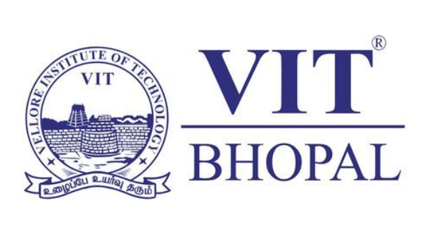
CSE0001 – Digital Literacy Project Report

Course: CSE0001 – Digital Literacy
University: VIT Bhopal University
Student Name: Ananya Tiwari
Registration No: 25BAI11158
Branch: B.Tech Computer Science
with specialization in AI ML

Introduction

The Digital Literacy project proved to be a deeply enriching experience that reshaped the way I perceive and interact with technology. Before undertaking this project, I viewed technology largely as a collection of convenient tools — something to be used when needed and set aside when not. However, this project challenged that surface-level understanding and pushed me to think more critically about how and why we use digital platforms, and the responsibilities that come with that usage.
Throughout the project, I explored a diverse range of digital platforms and activities, each carefully chosen to reflect the demands of today's academic and professional landscape. From designing an infographic that communicated ideas visually, to building and refining online profiles that represent one's professional identity, every task was grounded in real-world application. I also practiced drafting formal, professional emails — a skill that is deceptively simple yet critically important — and conducted research into the growing issue of cybercrime, which opened my eyes to the very real dangers that exist in digital spaces.
What made this project particularly meaningful was how each individual task connected to a larger picture. Together, they highlighted that digital literacy is not a single skill, but a dynamic set of competencies that spans communication, self-presentation, research, creativity, and safety. I also came to recognize how our everyday digital habits — the way we write, the platforms we engage with, and the content we share — quietly shape our academic reputation and professional image in ways we often overlook.
By the end of this project, I found myself not only more confident in navigating online tools and environments, but also more thoughtful and deliberate in how I choose to engage with them. This experience has instilled in me a stronger sense of digital responsibility, a greater appreciation for online professionalism, and a more cautious, informed approach to staying safe in an increasingly connected world.

Task 1 – Digital Literacy Awareness Infographic: Reflective Analysis

For this assignment, I utilized Canva as my primary design tool to develop a comprehensive one-page infographic focused on digital literacy awareness. The infographic was structured around three fundamental pillars: understanding what digital literacy encompasses, implementing safe internet practices, and cultivating a professional online presence. My decision to work with Canva was strategic—the platform offers an extensive library of pre-designed templates, vector icons, and customizable layouts that significantly lower the barrier to entry for users who may not have formal graphic design training.
The visual architecture of my infographic employed a deliberate organizational strategy. I incorporated intuitive iconography to represent abstract concepts visually, condensed complex information into digestible explanations, and implemented a color-coded system to differentiate between thematic sections. This approach was designed with cognitive load in mind: students should be able to scan the infographic quickly and extract key information without feeling overwhelmed by dense text or visual clutter.
Creating this digital literacy infographic served as both a practical application of design tools and a metacognitive exercise in understanding how digital communication shapes knowledge transfer. The experience reinforced that effective digital literacy education isn't simply about disseminating information—it's about crafting messages that are visually accessible, intellectually honest, and designed with the audience's needs at the forefront. Moving forward, I recognize that developing true digital literacy requires continuous learning, critical reflection on our own digital practices, and a commitment to ethical, responsible communication in increasingly digital spaces.
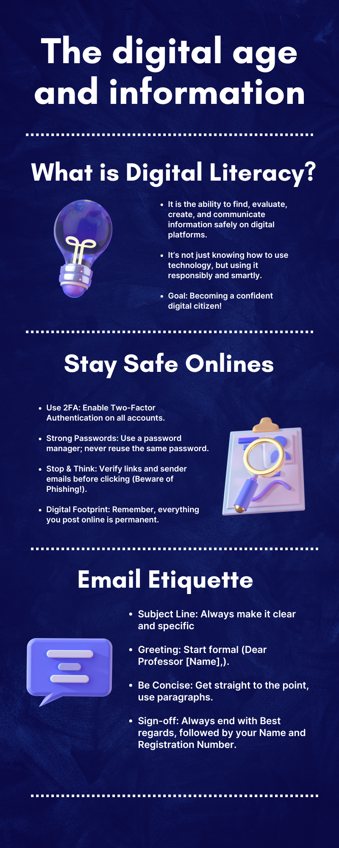

Task 2: Student Digital Portfolio

In this task, I created or updated my profiles on GitHub, LinkedIn, and Kaggle. I chose these three platforms because each serves a different professional purpose. GitHub is useful for storing and showcasing coding projects, LinkedIn helps build a professional network and academic identity, and Kaggle introduces students to data science and practical problem-solving.
On GitHub, I created a profile README that includes my name, branch, year, and my learning goals. On LinkedIn, I completed my education details with my current degree and university. Kaggle gave me exposure to how students can participate in beginner-level datasets and challenges. Over the next four years, I plan to use GitHub to document projects, LinkedIn to build my professional network, and Kaggle to strengthen my analytical and technical skills.
This task taught me that digital presence should focus on authenticity rather than exaggeration. A simple and genuine profile can create better long-term opportunities than a profile built only for appearance.
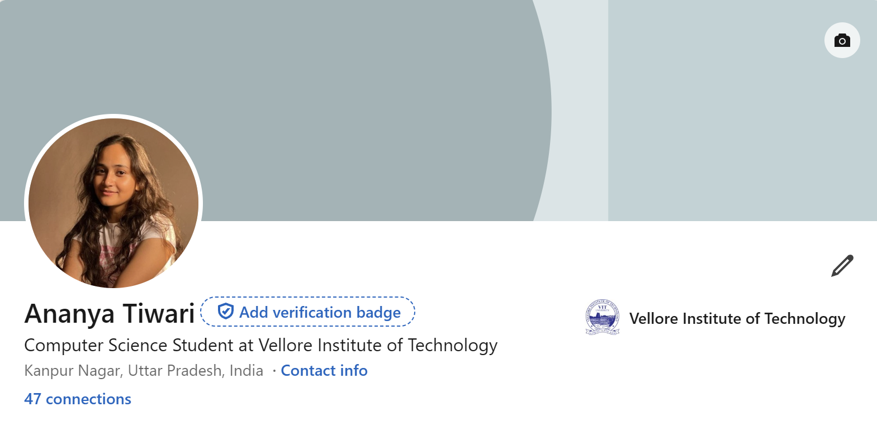

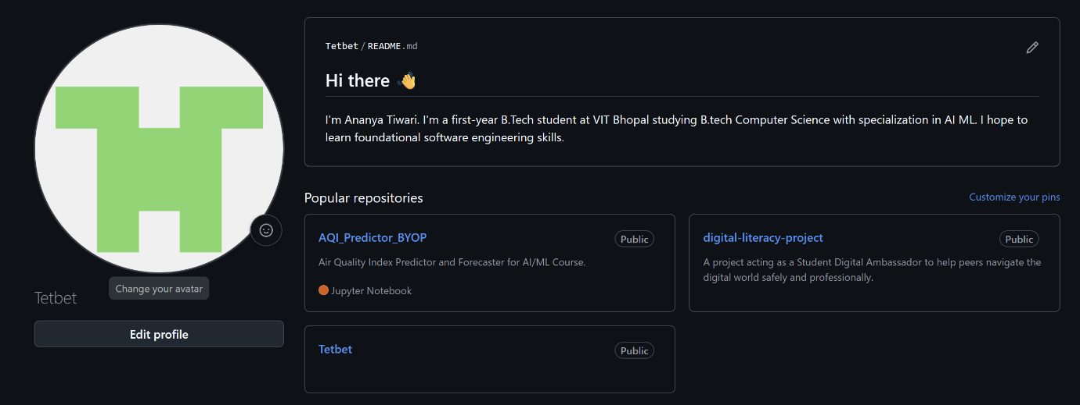

Task 3: Platforms

For this task, I used HackerRank for coding practice and Google Forms for collaboration tools. On HackerRank, I completed a beginner-level challenge, which helped me understand how coding platforms improve logical thinking and problem-solving. It also introduced me to the importance of regular practice and skill-based learning.
For the collaboration part, I created a Digital Literacy Awareness Quiz using Google Forms with five questions, including multiple-choice and short-answer types. I linked the responses to Google Sheets to observe how data collection and response management work in real time. This task showed me how digital collaboration tools can be used not only for assignments but also for surveys, feedback, and academic teamwork. The most valuable learning from this task was that digital platforms can make academic work more interactive and efficient. However, their effectiveness depends on how responsibly students use them.
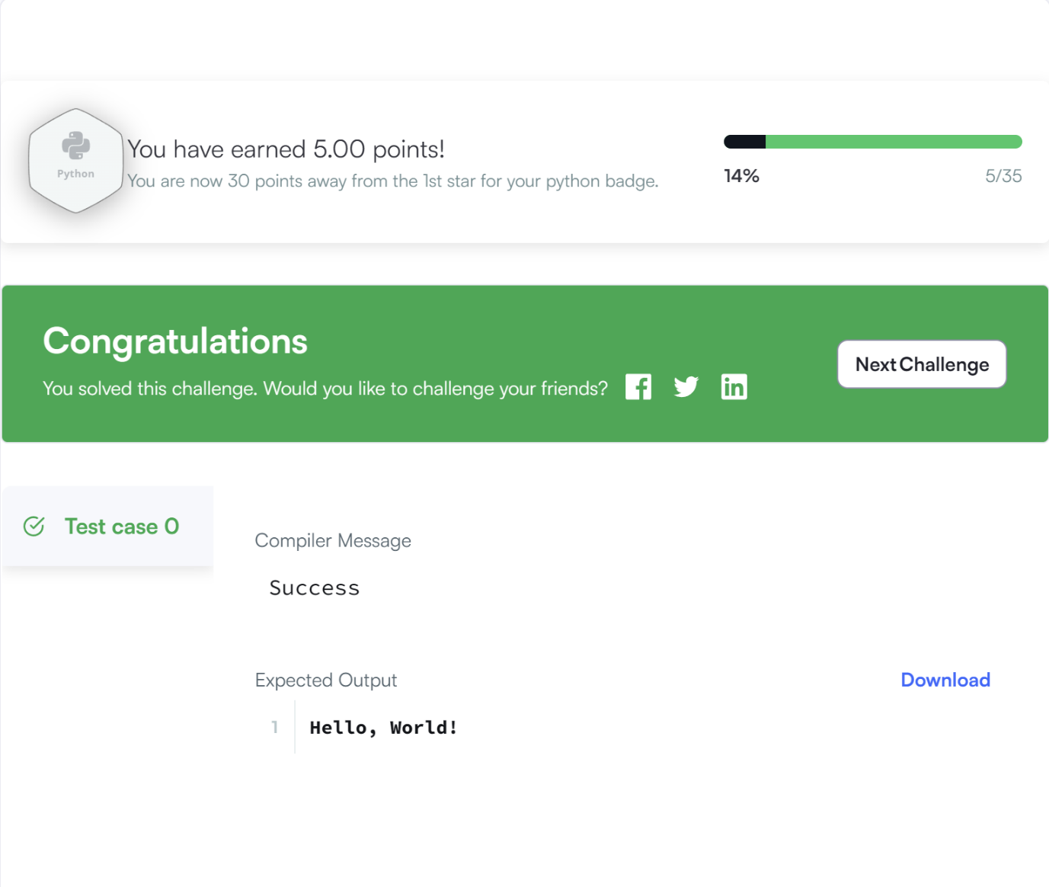
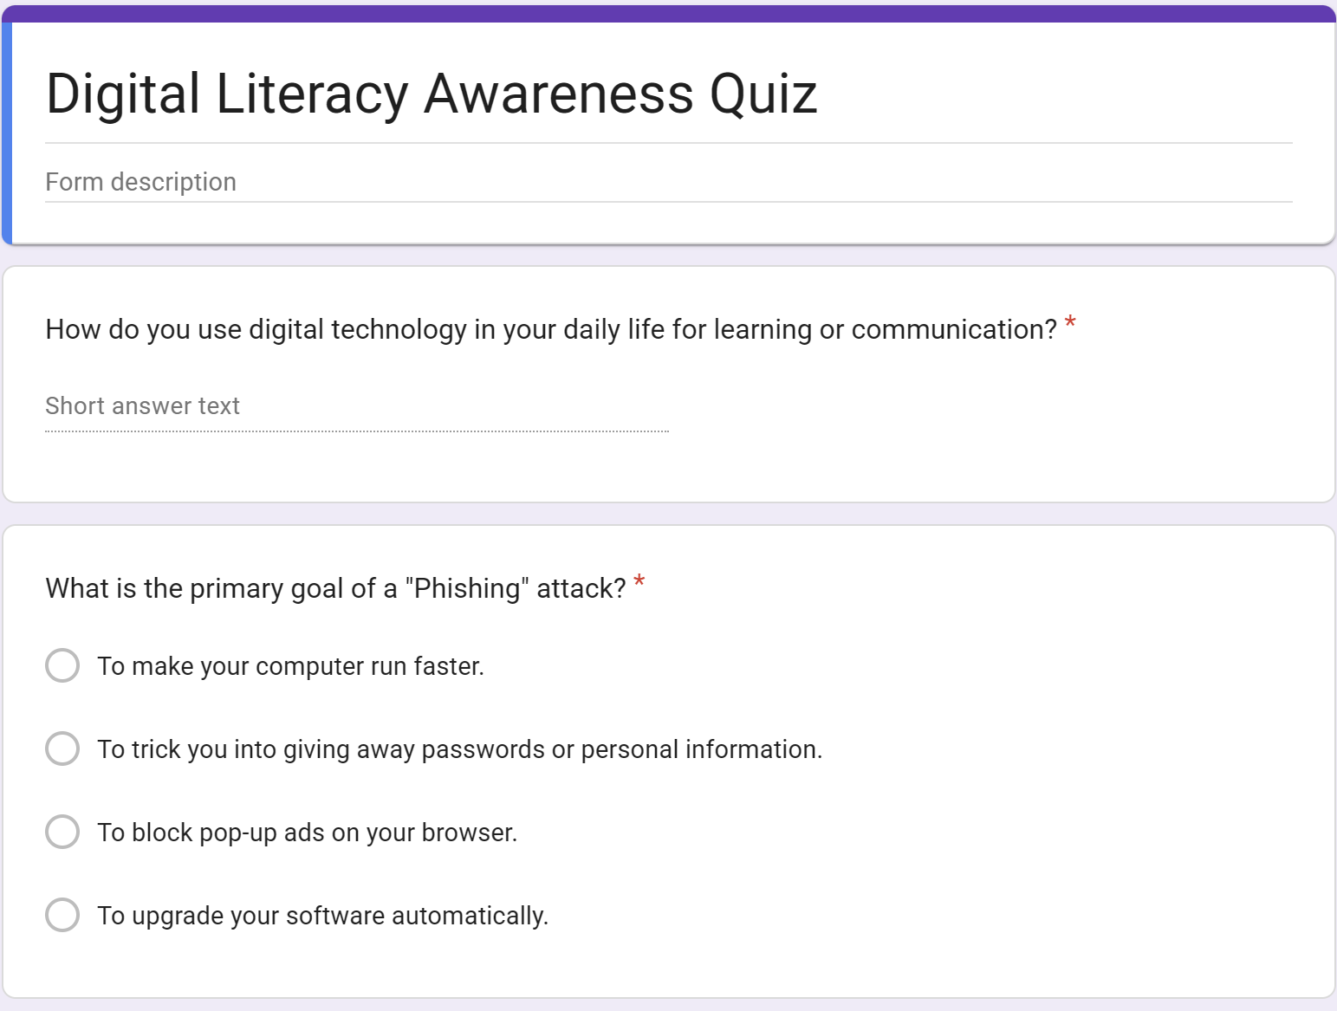
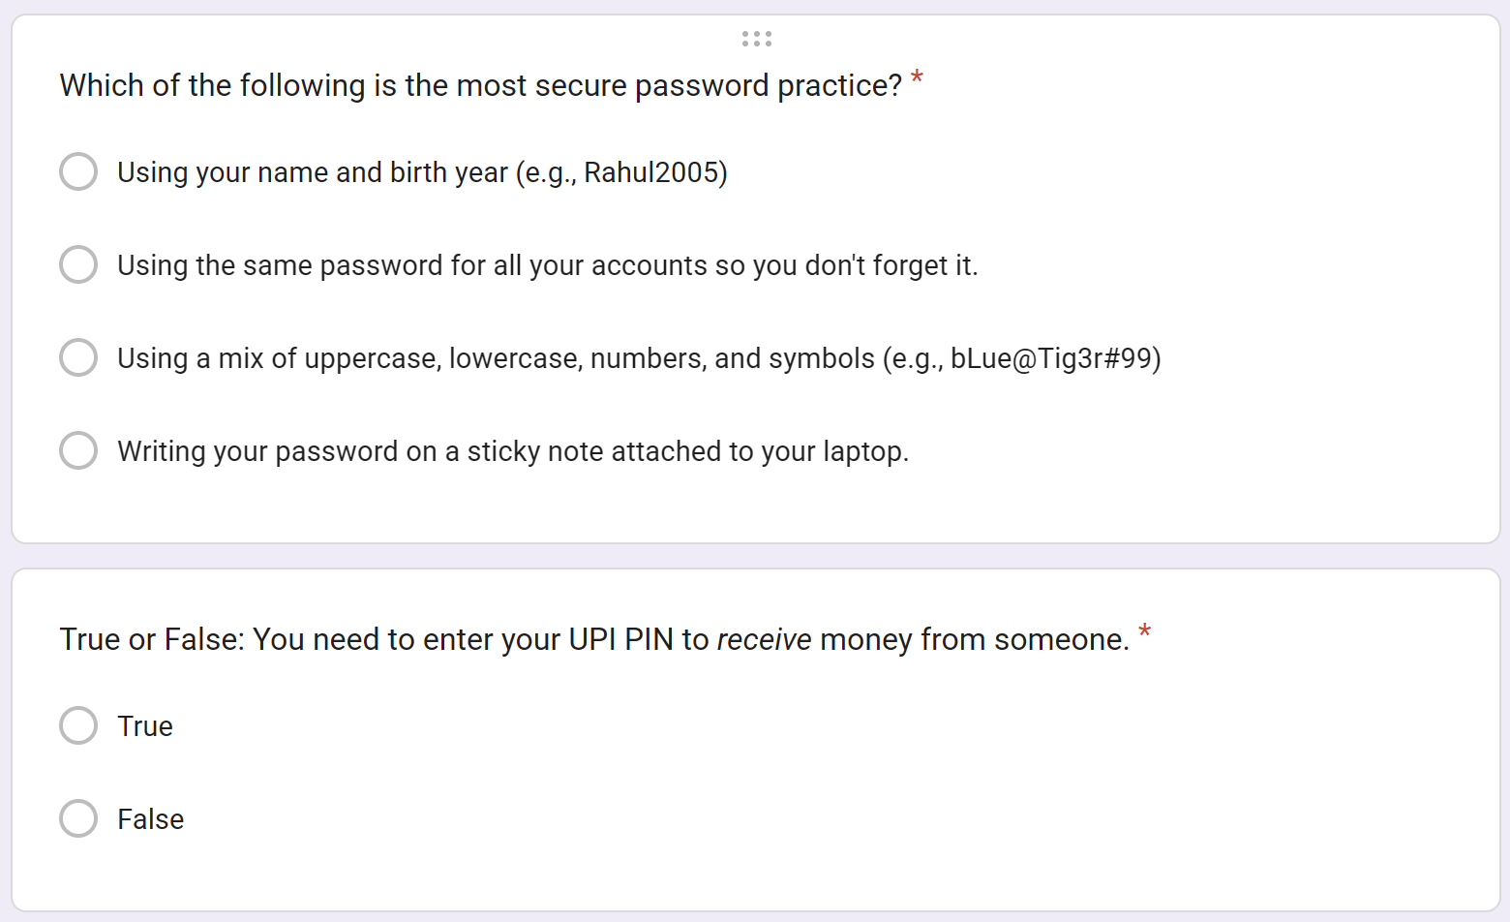
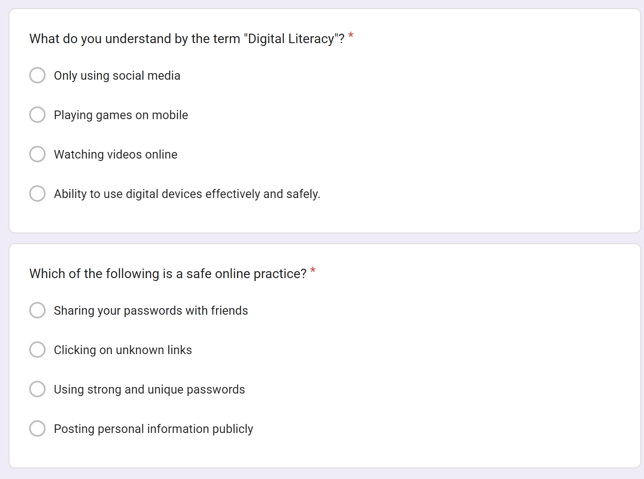

Task 4 – Professional Email & Etiquette

This task focused on professional communication. I drafted two emails: one requesting an assignment extension from a professor and another expressing interest in a summer internship. While writing these emails, I learned that digital communication is not only about sharing information but also about tone, respect, and structure.
A common problem among students is carrying casual chat habits into formal emails. For example, a short message like “Send recommendation ASAP” may sound rude even if the request is genuine. A better approach is to include a clear subject line, respectful greeting, proper explanation, and professional sign-off.
I also created a social media do’s and don’ts checklist, which emphasized responsible posting, privacy, and respectful online behavior. This task taught me that professionalism in communication directly affects perception, opportunities, and credibility.

Task 5– Cybercrime Awareness

For this task, I researched UPI and online payment fraud, which is one of the most common cyber threats faced by students in India. I created a case study explaining how scammers use urgency, fake payment links, and QR codes to trick users into entering their UPI PIN. I also prepared a prevention checklist that included tips such as never sharing OTPs, verifying QR codes, and reporting fraud immediately to 1930 or the National Cyber Crime Portal.
What surprised me most was how such simple tricks can lead to serious financial loss. Many people still believe that entering a UPI PIN is necessary to receive money, which scammers misuse. The one
habit I will personally change is verifying every financial request before taking action, especially when urgency is involved.
This task helped me understand that cyber safety depends on both awareness and behavior. Knowing risks is important, but consistently applying safe habits is what truly prevents fraud.

Conclusion

This Digital Literacy project gave me practical exposure to the most important digital skills required in academic and professional life. It improved my understanding of visual communication, professional identity, collaboration tools, email etiquette, and cyber awareness. More importantly, it helped me realize that digital literacy is not just technical usage but also ethical, professional, and responsible decision-making. I now feel more confident in using online platforms for learning and career growth, while also being more aware of digital safety and professionalism.

